Time-Series Anomaly Imputation Using Diffusion Models Validated by Diffusion-Based Anomaly Detection

Marcia Hon
Environmental Applied Science and Management
Toronto Metropolitan University
Toronto, Canada marcia.hon.29@torontomu.ca
Dr Bala Venkatesh
Electrical Engineering
Toronto Metropolitan University
Toronto, Canada
bala@torontomu.ca
Dr Naimul Khan
Electrical Engineering
Toronto Metropolitan University
Toronto, Canada
n77khan@torontomu.ca

Abstract— Research in anomaly detection in Smart Meter time-series data is, generally, evaluated using synthetically created anomalies. These anomalies often fail to adequately capture the complexity of real-world attributes. As a solution, we investigate a novel Diffusion-based Anomaly Imputation Model to generate realistic anomalies which are then evaluated based on its impact on anomaly detection performance (using a novel Residual-Spectral Diffusion Inpired Model). We focus on 7 anomalies (StepChange, MultiStepChange, Mirror, Repeating, StuckMAX, StuckMIN, and PowerCycling) across 14 NILM (Non-Intrusive Load Monitoring) datasets: REFIT (Houses - 1, 2, 3, 5, 7, 9, 15), UKDALE (Houses - 1, 2, 5), AMPds2 (House - 1), GREEND (Houses - 0, 1, 3). The results show that diffusion imputation does not degrade overall detectability whereby the relative ordering of anomaly difficulty is, for the most part, preserved. The distribution analysis shows that diffusion anomalies, generally, overlap with normal behaviour. Hence, Diffusion Imputation reshapes anomalies rather than inserting trivial or noisy characteristics, thus, producing context-aware anomalies appropriate for evaluation. In conclusions, our proposed model provides a realistic approach for benchmarking anomaly detection methods in Smart Meters.
Keywords— Time Series Anomaly Detection, Guided Diffusion Model, Diffusion Model Imputation, Anomaly Detection with Diffusion Model, NILM

Introduction
Non-Intrusive Load Monitoring (NILM), developed in the early 1990s, has become a critical framework for understanding individual appliance-level energy consumption from aggregate smart-meter data. Today, we have evolved to the era of Generative AI, accordingly, new methods have been developed. Nevertheless, throughout, evaluating anomaly detection remains a challenge due to the scarcity of real and labelled anomaly data. Consequently, most studies rely on synthetically inserted handmade anomalies, that often exaggerate characteristics and fail to capture the contextual and temporal complexity of real-world abnormal behavior.
Diffusion models have recently demonstrated strong performance in time-series forecasting, generation and imputation. With regards to imputation, the general focus has been on restoring missing or corrupted normal data. Accordingly, the critical question we ask is can diffusion models be used to generate realistic time series anomalies that preserve detectability while better reflecting the structure of normal behavior?
In this work, we address this gap by introducing a Diffusion Anomaly Time-Series Imputation Model and a complementary Residual-Spectral Diffusion Inspired Model for Anomaly Detection. We conduct a large-scale evaluation across 14 widely used NILM datasets and systematically analyze 7 representative anomaly types with diverse temporal, amplitude, and frequency characteristics. Finally, we directly compare Imputed Anomalies with traditionally Inserted Anomalies to assess whether imputation preserves anomaly detectability while remaining close to the normal data input distribution.
Across multiple metrics, diffusion-imputed anomalies exhibit comparable detectability to inserted anomalies, while demonstrating greater statistical connection with normal behavior. These findings validate diffusion-based anomaly imputation as a realistic and effective avenue for anomaly generation and benchmarking in NILM time-series analysis.
Overall, our research makes the following contributions:
• We conduct a comprehensive evaluation using 14 popular NILM datasets: REFIT (Houses 1, 2, 3, 5, 7, 9, 15), UKDALE (Houses 1, 2, 5), AMPds2 (House 1), and GREEND (Houses 0, 1, 3). These datasets are global with REFIT/UKDALE from United Kingdom, AMPds2 from Canada, and GREEND from Austria and Italy.
• We design and evaluate 7 synthetic anomaly types: StepChange, MultiStepChange, Mirror, Repeating, StuckMAX, StuckMIN, and PowerCycling. These cover a wide range of realistic temporal, amplitude, and frequency characteristics. Abrupt anomalies are those with sudden and sharp changes: StepChange, MultiStepChange, StuckMAX, and StuckMIN. Whereas, structural anomalies with patterns are demonstrated by Mirror, Repeating, and PowerCycliing.
• We introduce a novel Diffusion Model for Anomaly Time-Series Imputation. This is the first diffusion-based approach designed to impute anomalies rather than normal values in Time Series.
• We propose a novel Residual-Spectral Diffusion Model for Time-Series Anomaly Detection.
• We empirically demonstrate that diffusion-imputed anomalies perform comparably to traditionally inserted anomalies. Additionally, we prove that imputed anomalies are more related to normal data compared with inserted anomalies. Hence, validating anomaly imputation as a realistic and effective alternative for evaluation.
To the best of our knowledge, this work is the first to apply a Diffusion Model for Anomaly Imputation in Time Series that generates comparably realistic anomalies while preserving the statistical behavior of normal NILM data. In addition, our Residual-Spectral Diffusion Anomaly Detection was first introduced in our prior work, "DANDY: Dual-stage Appliance-level NILM and Diffusion sYstem" and is reused here to validate anomaly detection.
The paper is followed by the following sections: Related Works, Methodology, Results, Discussions, Conclusions, and Future Works.

Related Works
This section consists of nine sections: Anomaly Detection in Time-Series Data, Anomaly Detection in NILM, Synthetic Anomaly Generation for Evaluation, Diffusion Models for Time-Series Modeling, Diffusion-Based Imputation for Time-Series Data, Diffusion Models for Anomaly Detection, Limitations of Existing Approaches and Research Gap, Positioning of this Work, and Evaluation Metrics for Imbalanced Anomaly Detection.

Anomaly Detection in Time-Series Data
Time series have the following common characteristics: stationarity, auto-regressive, cycles, trends, structural breaks, and seasonality [1]. With regards to time-series anomaly detection, there are three main types of anomalies: point, contextual, and collective. From these there are various categories of anomaly detection [2]: statistical, clustering, deviation, distance, and density. In [3] they use LSTM-GAN (Long-Short Term Memory – Generative Adversarial Network) successfully to perform anomaly detection on PHM (Prognostic and Health Management). In [4] they use Dis-AE-LSTM (GAN and LSTM-RNN combination) using reconstruction error to perform anomaly detection comparing with Autoencoder, EBM, LSTM-AD, LSTM-Enc-Dec, and DAGMM. Traditionally, GAN (Generative Adversarial Network) was used for anomaly detection with images, hence in [5], they propose to transform a time series into a “distance image” and then do anomaly detection with GAN. In our paper, we use the latest class of Deep Learning (specifically – a variant of Generative AI) called Diffusion Model to perform Anomaly Detection in Time Series Data.

B. Anomaly Detection in NILM
NILM (Non-Intrusive Load Monitoring) was first introduced in 1992 by George W. Hart of MIT [6]. His goal was to identify the active appliance to give residents the ability to better control their electricity usage. There have been many models to classify the appliances. According to our research, anomaly detection in NILM is restricted to either appliance-level or aggregate-level with yet no documented methodology to find an anomalous appliance out of the aggregate household energy consumption. In [7] they successfully leverage GAN to detect anomalies at the appliance level such as kettle, refrigerator, washing machine, microwave, and dish washer. In [8], they created anomaly detection using CUSUM (Cumulative Sum) at the appliance level. In [9] a multi-stage deep learning architecture is introduced and using transfer learning successfully finds aggregate anomalies in REDD and SimDataset. In [10] they compare various combinations of AE (Autoencoders), VAE (Variational Autoencoders), and LSTM (Long-Short Term Memory) to perform anomaly detection of aggregate building consumptions (Dutch and Italian dataset). In our project, we are the first to implement Diffusion Anomaly Detection in the NILM and Smart Meter domain.

C. Synthetic Anomally Generation for Evaluation
A core problem with research in anomaly detection is finding the appropriate dataset. Originally, most anomaly detection was trivial and resorted to handmade thresholds such as the ubiquitous 3-sigma threshold. These characteristics implied that a Deep Learning model was overkill and, thus, anomalies could be detected with very simple statistical one-liners. In [11], they highlight the following issues of a poor anomaly dataset: triviality, unrealistic anomaly density, mislabeled ground truth, and run-to-failure bias. In [12] they augment the prevalent “UCR Time Series Archive” from 85 to 128 datasets addressing the following criticisms: unrealistic assumptions, provenance of the data is poor, data already normalized, individual data sets are too small, data sets are not reflective of real-world problems, and benchmark results are from a single train/test split. They further suggest that anomaly research tend to “cherry pick” rather than seek appropriate justification and explanation. In our research, we seek to create realistic and non-trivial anomalies based on Diffusion Imputation.

D. Diffusion Models for Time-Series Modeling
Diffusion Models are a relatively new form of Generative AI pioneered in 2015 [13]. At first its usage was directed to image (such as the famous DALL-E), video, text, and recently to time series and LLM (Large Language Models). Regarding time series, the methodologies include forecasting, generation, imputation, and anomaly detection. The last two, we cover in this paper. Essentially, diffusion models work by progressively perturbing data until it becomes random in the forward process and then recover this data in a backward process that undoes the added noise. Hence, it effectively learns the distribution of the input dataset. There are three core approaches for diffusion [14]: Denoising Diffusion Probabilistic Models (DDPMs), Score-based Generative Models (SGMs), and Stochastic Differential Equations (SDEs). With generation, in [15] they propose EnergyDiff which is a DDPM-based universal energy time series generation framework, similarly, [16] also produces a DDPM for generation of household electricity demand. Imputation will be described next because it is a core aspect of this research.

E. Diffusion-Based Imputation of Time-Series Data
The traditional purpose of time series imputation is to fill gaps with normal data to facilitate downstream tasks that relies on having complete data. In [17] they introduce ShapeDiff that performs shapelet-based anomaly detection on data whose missing and corrupted regions are diffusion imputed with normal signals. In [18] they propose SSSD (structured state space diffusion) model for time series imputation, at its release in 2023, it was a top performer. Another success is [19] whereby they propose CSDI (Conditional Score-based Diffusion model for Imputation). In [20], they create tBN-CSDI (Time-varying Blue Noise-based Conditional Score-based Diffusion model for Imputation) which uses blue noise (low frequencies are suppressed and high frequencies dominate) instead of white noise (random) for diffusion and they find that it performs better. In [21] they create CTSDiff (Conditional Time Series Diffusion) to successfully impute high-speed train’s Prognostics and Health Management (PHM) system. As of the time of our publication, we have not found instances of Diffusion Imputation of Anomalous Data in Time Series.

F. Diffusion Models for Anomaly Detection
According to [22], there are three prominent diffusion models for anomaly detection: DDPMs (Denoising Diffusion Probabilistic Models), DDIMs (Denoising Diffusion Implicit Models), and Score SDEs (stochastic differential equations). There are also three types of anomaly detection: reconstruction-based, density-based, and hybrid of both. Anomaly detection includes the domains of image, video, and time series. In [23], DDPMs and DiTs (Diffusion Transformers) outperformed Isolation Forests, One-Class SVMs, and COPOD (Copula-based outlier detection). In [24] they investigate DDPMs performance and find it is computationally expensive, hence, they propose DTE (Diffusion Time Estimation). In [25] they learn that diffusion models suffer from “faithfulness hallucination” and “catastrophic forgetting” with the progression of patterns, accordingly, they proposed CDAD (Continual Diffusion model for Anomaly Detection). Our approach is a Residual-Spectral Diffusion model which has not been done before.

G. Diffusion Models for Anomaly Inpainting
In the literature, there is a Diffusion Model technique known as Anomaly Inpainting. It is essentially Imputation of Anomalous values, however, instead of being designated as “Anomaly Imputation” it is called “Anomaly Inpainting”. From our research, there has not been many explorations of this topic. Additionally, the papers that we found solve Anomaly Inpainting exclusively with images. In [26], they propose MAGIC (Mask-guided inpainting with multi-level perturbations and Context aware alignment) to generate anomalies in images so as to help solve the normal vs anomaly dataset imbalance. Similarly in [27], they propose DefectFill, a novel method for realistic anomaly generation that requires only a few reference defect images. Our research expands on Anomaly Inpainting from images (as is done in the literature) to Time Series. Additionally, we have decided to use the term Anomaly Imputation rather than Anomaly Inpainting.

H. Limitations of Existing Approaches and Research Gap
Throughout the literature, when investigating anomaly detection, researchers almost unanimously refer to synthesized/hardcoded anomalies. Overall, real-life anomalies are very difficult to gather, hence, the overwhelming dependence on simplistic synthetic anomalies. By leveraging Imputation with Diffusion Models, we seek to bridge this gap by automating a process that creates anomalies within the context of the normal data. At this point in time, Imputation for Diffusion Models are focused on imputation of normal values such as for ECG (Electrocardiogram) data that is missing. We are the first to perform Diffusion Imputation Time Series for anomalies rather than normal values. Additionally, our version of Anomaly Detection Diffusion Model was first introduced in our previous paper on “DANDY”. Overall, the universal trend, is to move towards Generative AI models that can produce coherent anomalous behaviour and verify the existence of anomalies. In this research, we address these gaps by systematically evaluating our proposed architecture through a controlled comparison of traditionally inserted anomalies and diffusion-imputed anomalies, enabling an explicit assessment of how anomaly construction influences detectability.

I. Positioning of this Work
We advance time-series anomaly analysis by introducing diffusion for anomaly imputation and evaluating it by comparing with the ubiquitous inserted anomalies. Traditionally, diffusion-based imputation performed on only normal values, whereas we generate structurally coherent anomalous segments. Our anomaly detection is also diffusion based leveraging residual and spectral aspects of the data: temporal and frequency residual reconstruction. It is the anomaly detection framework we created in the previous paper (DANDY). These contributions, position this work to examine the applicability of Diffusion Anomaly Imputation.

J. Evaluation Metrics for Imbalanced Anomaly Detection
As is the nature of the anomaly datasets used for research, there is a very high imbalance generally of normal versus anomaly. Hence, this renders accuracy and precision as unreliable, thus, necessitating other metrics: ROC-AUC, PR-AUC, Separation Delta, and Cohen’s d.

The following sections are Methodology, Results, Discussions, Conclusions, and Future Works.

Methodology
This section is separated into: Dataset Selection, Anomaly Selection, Metrics Explanations, Anomaly Inserted, Anomaly Imputation - Diffusion, and Anomaly Detection with Diffusion.

Dataset Selection
In this research, fourteen typical NILM datasets were leveraged from various locations around the world. They were REFIT (United Kingdom), UKDALE (United Kingdom), GREEND (Austria & Italy), and AMPds2 (Canada). All datasets were specifically of the Fridge appliance due to its prevalence. The datasets contained the timestamp for 15-minute intervals of the active power, thus, mimicking Smart Meter measurement analysis. The following TABLE I lists the size of the datasets, first and last dates, the minimum and maximum active power, and the active power range. In the table, residences are R – REFIT, U – UKDALE, G – GREEND, and A – AMPds2. Also, the residence numbers correspond to the house number.

Table I. Description of Datasets
Res | Rows | First | Last | Min | Max | Range
R_01 | 61340 | 2013-10-09 | 2015-07-10 | 0 | 376027 | 376027
R_02 | 59273 | 2013-09-17 | 2015-05-28 | 0 | 24719 | 24719
R_03 | 59007 | 2013-09-25 | 2015-06-02 | 0 | 280576 | 280576
R_05 | 62241 | 2013-09-26 | 2015-07-06 | 0 | 60672 | 60672
R_07 | 58865 | 2013-11-01 | 2015-07-08 | 0 | 35328 | 35328
R_09 | 54535 | 2013-12-17 | 2015-07-08 | 0 | 335894 | 335894
R_15 | 54468 | 2013-12-17 | 2015-07-08 | 0 | 26485 | 26485
U_01 | 153006 | 2012-12-14 | 2017-04-26 | 0 | 32362 | 32362
U_02 | 13665 | 2013-05-20 | 2013-10-10 | 0 | 12440 | 12440
U_05 | 13159 | 2014-06-29 | 2014-11-13 | 0 | 17228 | 17228
G_00 | 29812 | 2013-12-06 | 2014-10-13 | 0 | 1704062 | 1704062
G_01 | 22333 | 2014-03-12 | 2014-10-30 | 0 | 62871 | 62871
G_03 | 21145 | 2014-03-24 | 2014-10-30 | 0 | 106273 | 106273
A_01 | 70080 | 2012-04-01 | 2014-04-01 | 0 | 7022 | 7022

B. Anomaly Selection
We decided to model 7 types of anomalies. Each anomaly was created to mimic real-life appliance electricity consumption anomalies. The following table lists the anomalies and their descriptions.

Table II. Description of Anomalies
Anomaly | Description
StepChange | A sudden, large, and sustained jump in power, mimics sensor faults or abnormal switching.
MultiStepChange | A series of abrupt power jumps simulating erratic or degrading appliance behavior.
Mirror | A segment of power data reversed mimics data corruption or reverse logging.
Repeating | Duplications simulating loops or stuck cycles in control.
StuckMAX | Continuously stuck at its highest level, simulating runaway or failed components.
StuckMIN | Continuously stuck at its lowest level, simulating sensor errors or idle-state bugs.
PowerCycling | A rapid switching on/off, simulating relay bounce, unstable power supply, or hardware faults.

In addition, the following full days were picked to insert anomalies:

- REFIT_House01: 2015-03-09
- REFIT_House02: 2015-01-26
- REFIT_House03: 2015-02-02
- REFIT_House05: 2015-03-02
- REFIT_House07: 2015-03-09
- REFIT_House09: 2015-03-23
- REFIT_House15: 2015-03-16
- UKDALE_House01: 2016-06-06
- UKDALE_House02: 2013-09-16
- UKDALE_House05: 2014-10-20
- AMPds2_House01: 2013-11-11
- GREEND_House00: 2014-08-18
- GREEND_House01: 2014-09-15
- GREEND_House03: 2014-09-22

The following FIGURES I and II are examples of the Anomalies as applied to REFIT_House01 for both Anomalies Inserted and Anomalies Inserted with Diffusion Imputation.

FIGURE I. Inserted Anomalies
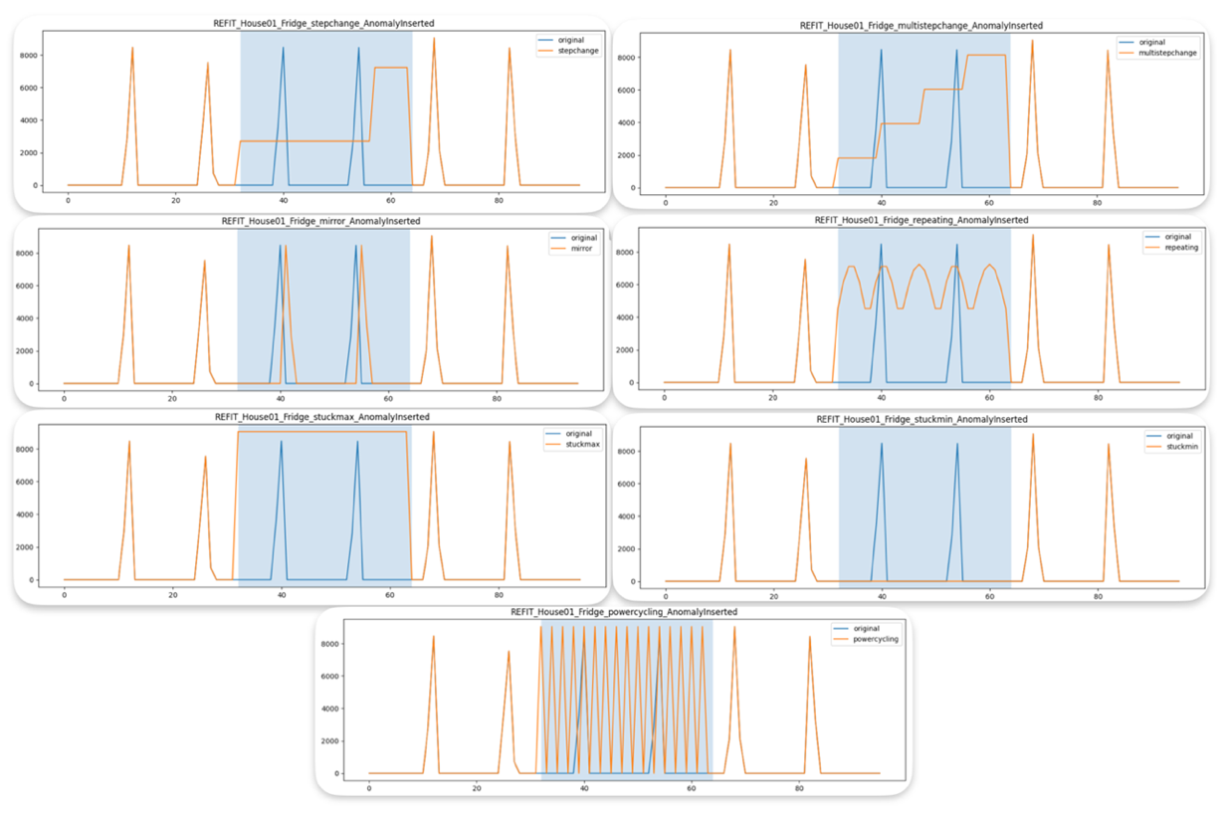

FIGURE II. Imputed Anomalies

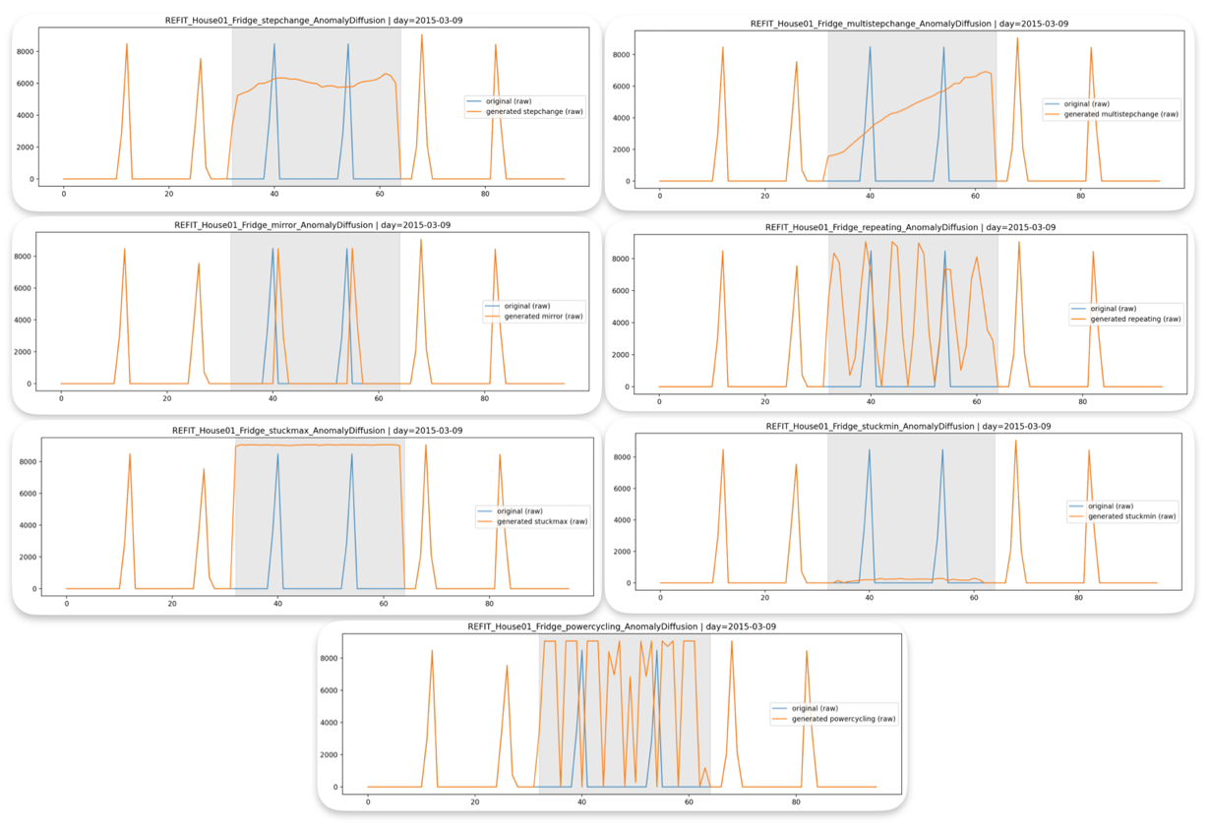

C. Metrics Explanations
In this experiment, eight metrics were used to evaluate Anomaly Evaluation: Accuracy, Precision, Recall, F1-Score, Separation Delta, Cohen’s d, ROC-AUC, and PR-AUC. The next TABLE III lists the theoretical range, the meaning behind the metric, and a reference to explain these metrics. Following TABLE III, we have further descriptions of the metrics.

- TP = true positives (anomalies correctly detected)
- TN = true negatives (normal points correctly detected)
- FP = false positives (normal flagged as anomaly)
- FN = false negatives (missed anomalies)

TABLE III. Metric Definitions

Metric | Theoretical Range | What Indicates Better Performance | Formula
Accuracy | [0, 1] | Overall correctness across all predictions | $$Accuracy= \frac{TP+TN}{TP+TN+FP+FN}$$
Precision | [0, 1] | How many detected anomalies were correct | $$Precision= \frac{TP}{TP+FP}$$
Recall | [0, 1] | How many true anomalies were detected | $$Recall=\frac{TP}{TP+FN}$$
F1-score | [0, 1] | Balance between precision and recall | $$F1=2 ∙ \frac{Precision ∙Recall}{Precision+Recall}$$
Separation Δ | (−∞, +∞) | Identifies the separation. | $$∆ = μ_{anomaly}- μ_{normal}$$
Cohen’s d | (−∞, +∞) | Shows how strong the separation is. | $d= \frac{μ_{anomaly}- μ_{normal}}{σ_{pooled}}$, $σ_{pooled}= \sqrt{\frac{σ_{anomaly}^{2}+ σ_{normal}^{2}}{2}}$
ROC-AUC | [0, 1] | Can Normal and Anomaly be separated? | $ROC-AUC= \int_{0}^{1}{TPR\left(FPR\right)d\left(FPR\right)}$, $TPR=\frac{TP}{TP+FN}$, $FPR=\frac{FP}{FP+TN}$
PR-AUC | [0, 1] | When it is Anomaly, is it true? | $$PR-AUC= \int_{0}^{1}{Precision\left(Recall\right)d\left(Recall\right)}$$

The following gives more detailed understanding of the metrics used.

Accuracy
- Accuracy tells you the percentage of points classified correctly (either normal or anomalous).
- Generally, values close to 1 are good imbalanced datasets. However, with heavily skewed datasets, accuracies will be high but detect anomalies poorly

Precision
- How often the model is correct when predicting an anomaly.
- Generally, high values are better. However, in skewed datasets, very low precision values are expected.

Recall
- How many of the true anomalies the model successfully detects.
- Higher means fewer missed anomalies, lower indicates the model misses anomalies.

F1-score
- Balances precision and recall into a single measure.
- Higher values indicate a better trade-off, however, in skewed settings it is unclear.

Separation Delta
- Measures how far the average anomaly score is from the average normal score.
- Values close to zero mean anomalies are like normal behaviour.

Cohen’s d
- Measures how strong the difference is between anomaly and normal score distributions relative to their natural variability.
- Values near zero indicate weak separation, around 0.2–0.5 indicate small to moderate differences, and above 0.8 indicate strong separation.

ROC-AUC
- Measures how well the model can rank anomalies above normal samples.

PR-AUC
- How good the model is at catching real anomalies without raising too many false alarms.

D. Anomaly Inserted
As previously stated, there are 7 anomalies: StepChange, MultiStepChange, Mirror, Repeating, StuckMAX, StuckMIN, and PowerCycling. In this section, we detail how each of these anomalies are directly inserted into the anomaly date for a given dataset. The algorithms are explained below:

- StepChange
This consists of two plateaus. First, at 30% of max height in the day, and second, at 80% height. Clip to fit the min-max range of the day.

- MultiStepChange
Between 20% and 90%, add four equally spaced plateaus. Clip to fit the min-max range of the day.

- Mirror
Reverses active power according to time.

- Repeating
Split into 5 chunks with a sinusoid having center at 50% max with amplitude of 30%. Clip to fit the min-max range of the day.

- StuckMAX
Set all values to be the max of the day.

- StuckMIN
Set all values to be the min of the day.

- PowerCycling
Alternate between max and min of the day.

All these anomalies are inserted in the specified anomaly date using the values inherent in that anomaly date.

E. Anomaly Imputation - Diffusion
For Anomaly Imputation, we propose a Diffusion model. This was chosen with the explicit goal of making synthetic anomalies be derived based on the normal data distribution. Hence, as compared with directly inserted anomalies, the anomalies produced with imputation are meant to be more probable given the normal dataset.

E.1 Training Process
First, we extract one full day and scale to [0,1]. There are 96 points to a day corresponding to 24 hours x 4 (4 x 15 minutes) = 96. We also sample a timestamp $t∼U\{1,…,T\}$ and Gaussian noise $ε∼N(0,I)$.

Now, we perform the Forward Diffusion with the following noise schedule ($β_{i}$):

$$x_{t}=\sqrt{{\overset{ˉ}{α}}_{t}} x_{0}+\sqrt{1-{\overset{ˉ}{α}}_{t}} ε$$  $$β_{1}≈{10}^{-4},β_{T}≈2×{10}^{-2}$$  $$α_{t}=1-β_{t},{\overset{ˉ}{α}}_{t}=\prod_{s=1}^{t}{α_{s}}$$ | (1)

Next, we identify the binary mask in the anomaly region. We pick a region $[s,e)$ (for your fixed middle third, $s=32,e=64$):
$$m_{i}=\left\{\begin{matrix}1 & s≤i<e \\ 0 & \text{otherwise}\end{matrix}\right.⇒m∈\{0,1\}^{96}$$  $$∣m∣=\sum_{i=1}^{96}{m_{i}}$$ | (2)
Next, we define the K anomaly classes (we have 7). Let the desired class be $k∈\{1,…,K\}$. Then:
$$c∈R^{K×96},c_{j,i}=\left\{\begin{matrix}m_{i} & j=k \\ 0 & j≠k\end{matrix}\right.$$ | (3)

Insert synthetic anomaly inside mask:

$x_{0}=x_{0}^{\text{clean}}⊙(1-m)+g_{a}(x_{0}^{\text{clean}},m)⊙m$ , whereby $g_{a}(⋅)$ is your anomaly injector and outside the mask it is your original day. | (4)
Then you do forward diffusion on this $x_{0}$ (the anomalous version):
Rearranging the Forward Process, we can calculate:

$ε=\frac{x_{t}-\sqrt{{\overset{ˉ}{α}}_{t}} x_{0}}{\sqrt{1-{\overset{ˉ}{α}}_{t}}}$ | (5)

Now, the neural network predicts the noise,

$${\hat{ε}}_{θ}=ε_{θ}\left(x_{t},t,m,c\right)$$  given the inputs of time/mask/class. | (6)
The masked noise is:
$$L_{ε}={∥\left(ε-{\hat{ε}}_{θ}\right)⊙m∥}_{2}^{2}$$  expanded to: $L_{ε}=\sum_{i=1}^{96}{m_{i}} (ε_{i}-{\hat{ε}}_{θ,i})^{2}$ | (7)

The reconstructed signal is:
$${\hat{x}}_{0}=\frac{x_{t}-\sqrt{1-{\overset{ˉ}{α}}_{t}} {\hat{ε}}_{θ}}{\sqrt{{\overset{ˉ}{α}}_{t}}}$$ | (8)

Hence the masked reconstruction is:
$$L_{x_{0}}={∥\left({\hat{x}}_{0}-x_{0}\right)⊙m∥}_{2}^{2}$$  expanded to: $L_{x_{0}}=\sum_{i=1}^{96}{m_{i}} ({\hat{x}}_{0,i}-x_{0,i})^{2}$ | (9)

The Gradient loss is:

$$L_{∇}=\sum_{i=1}^{95}{m_{i}^{∇}} ∣(∇{\hat{x}}_{0})_{i}-(∇x_{0})_{i}∣$$  $\left(∇x)_{i}=x_{i+1}-x_{i}, \right.$ $m_{i}^{∇}=m_{i} m_{i+1}$ | (10)

The Total Loss is:
$$L=L_{ε}+0.5 L_{x_{0}}+0.55 L_{∇}$$  0.5 and 0.55 were chosen empirically | (11)

In summary,
- Noise loss: learn how to remove noise
- Reconstruction loss: get the right values back
- Gradient loss: keep changes smooth and realistic

E.2 Inference Process
We begin by selecting a clean daily signal scaled to [0,1]: $x_{0}^{\text{clean}}∈R^{96}$.

Mirror is a special anomaly as it is not readily created with diffusion. Hence, we force the mirror behaviour in inference with the function “rev” which just reverses (mirrors) the dataset in that space.

Next, we force the values inside the mask location to be Gaussian and outside the mask to be the clean signal:
$$x_{T}=x_{0}^{\text{clean}}⊙(1-m)+z⊙m$$ | (12)

We now have two predictions to accomplish. One with the anomaly class (“c”) and one without class (“u”)
$${\hat{ε}}_{c}=ε_{θ}(x_{t},t,m,c) \\ {\hat{ε}}_{u}=ε_{θ}(x_{t},t,m,0)$$ | (13)

Hence, we have the Classifier-Free Guidance (CFG) as:
$\hat{ε}={\hat{ε}}_{u}+w({\hat{ε}}_{c}-{\hat{ε}}_{u})$, $w=3$ (a common value) | (14)

The reverse Diffusion step (DDPM reverse) removes a small amount of noise at each step:

$$x_{t-1}=\frac{1}{\sqrt{α_{t}}}\left(x_{t} − \frac{1-α_{t}}{\sqrt{1-{\overset{ˉ}{α}}_{t}}} \hat{ε}\right)+σ_{t}z, z∼N(0,I)$$  $$α_{t}=1-β_{t},{\overset{ˉ}{α}}_{t}=\prod_{s=1}^{t}{α_{s}}$$ | (15)

At each reverse step, we enforce locality meaning that we guarantee that values outside the mask are unchanged:
$$x_{t-1}=x_{t-1}⊙m+x_{0}^{\text{clean}}⊙(1-m)$$ | (16)
Finally, we unscale from [0,1] to the raw initial range: $x_{\text{anom}}=\text{unscale}(x_{0}^{\text{anom}})$.
E.3 Algorithm
Below, Algorithm I, is the algorithm for Anomaly Imputation Training and Inference.

Algorithm I: “Anomaly Imputation – Training and Inference”
Training Algorithm
Description | Equation
Extract one full day (96 samples) and scale to $\left[0 , 1\right]$ | $$x_{0}∈R^{96}$$
Sample diffusion timestep | $$t∼U\{1,…,T\}$$
Sample Gaussian noise | $$ε∼N(0,I)$$
Forward diffusion | $$x_{t}=\sqrt{{\overset{ˉ}{α}}_{t}} x_{0}+\sqrt{1-{\overset{ˉ}{α}}_{t}} ε$$  $$ε=\frac{x_{t}-\sqrt{{\overset{ˉ}{α}}_{t}} x_{0}}{\sqrt{1-{\overset{ˉ}{α}}_{t}}}$$
Define binary mask (anomaly region) | $$m∈\{0,1\}^{96}$$
Provide anomaly conditioning map | $$c∈R^{K×96}$$
Insert synthetic anomaly inside mask | $$x_{0}=x_{0}^{\text{clean}}⊙(1-m)+g_{a}(x_{0}^{\text{clean}},m)⊙m$$  $$x_{0}^{\text{clean}} is the original signal$$  $$g_{a} is the anomaly injection$$  Jitter is applied to the inserted anomaly
Predict noise with denoiser | $${\hat{ε}}_{θ}(x_{t},t,m,c)$$
Masked noise loss | $$L_{ε}=∥(ε-{\hat{ε}}_{θ})⊙m∥_{2}^{2}$$
Reconstruct clean signal | $${\hat{x}}_{0}=\frac{x_{t}-\sqrt{1-{\overset{ˉ}{α}}_{t}}{\hat{ε}}_{θ}}{\sqrt{{\overset{ˉ}{α}}_{t}}}$$
Masked reconstruction loss | $$L_{x_{0}}=∥({\hat{x}}_{0}-x_{0})⊙m∥_{2}^{2}$$
Gradient loss | $$L_{∇}=\sum_{i=1}^{95}{m_{i}^{∇}} ∣(∇{\hat{x}}_{0})_{i}-(∇x_{0})_{i}∣$$  $\left(∇x)_{i}=x_{i+1}-x_{i}, \right.$ $m_{i}^{∇}=m_{i} m_{i+1}$
Total loss | $$L=L_{ε}+0.5 L_{x_{0}}+0.55 L_{∇}$$

Inference Algorithm
Description | Equation
Select target day and scale | $$x_{0}^{\text{clean}}$$
Initialize noisy signal inside mask | If mirror:  $$x_{T}=x_{0}^{\text{clean}}⊙\left(1-m\right)+\text{rev}\left(x_{0}^{\text{clean}}\right)⊙m$$  Else:  $$x_{T}=x_{0}^{\text{clean}}⊙(1-m)+z⊙m$$  $$z∼N(0,I)$$
Conditional & unconditional predictions | $${\hat{ε}}_{c},{\hat{ε}}_{u}$$
Classifier-free guidance | $$\hat{ε}={\hat{ε}}_{u}+w({\hat{ε}}_{c}-{\hat{ε}}_{u})$$
Reverse DDPM step | $$x_{t-1}=\frac{1}{\sqrt{α_{t}}}\left(x_{t} − \frac{1-α_{t}}{\sqrt{1-{\overset{ˉ}{α}}_{t}}}\hat{ε}\right)+σ_{t}z$$
Enforce locality (hard constraint) | $$x_{t-1}=x_{t-1}⊙m+x_{0}^{\text{clean}}⊙(1-m)$$
If mirror | $$x_{t-1}[s:e]←\text{rev}(x_{0}^{\text{clean}}[s:e])$$
Repeat for $t=T→1$ | —
Unscale to raw units | $$x_{\text{anom}}=\text{unscale}(x_{0})$$

E.4 Architecture
Essentially, the architecture, below FIGURE III, takes a noisy 1D signal and a timestep as inputs. Then it learns how to remove the noise step-by-step. A UNet-shaped model is adopted with skip connections so that there is time awareness. Generally, a UNet is the traditional neural network model used for Diffusion because of the need to remove noise at many points throughout the Diffusion algorithm. The architecture performs the following:
- Looks at the noisy signal
- Knows how noisy it is at a certain point (time embedding)
- Extracts features at multiple levels
- Reuses earlier details via shortcuts (skip connections)
- Outputs the predicted noise

FIGURE iii. Anomaly Imputation Architecture
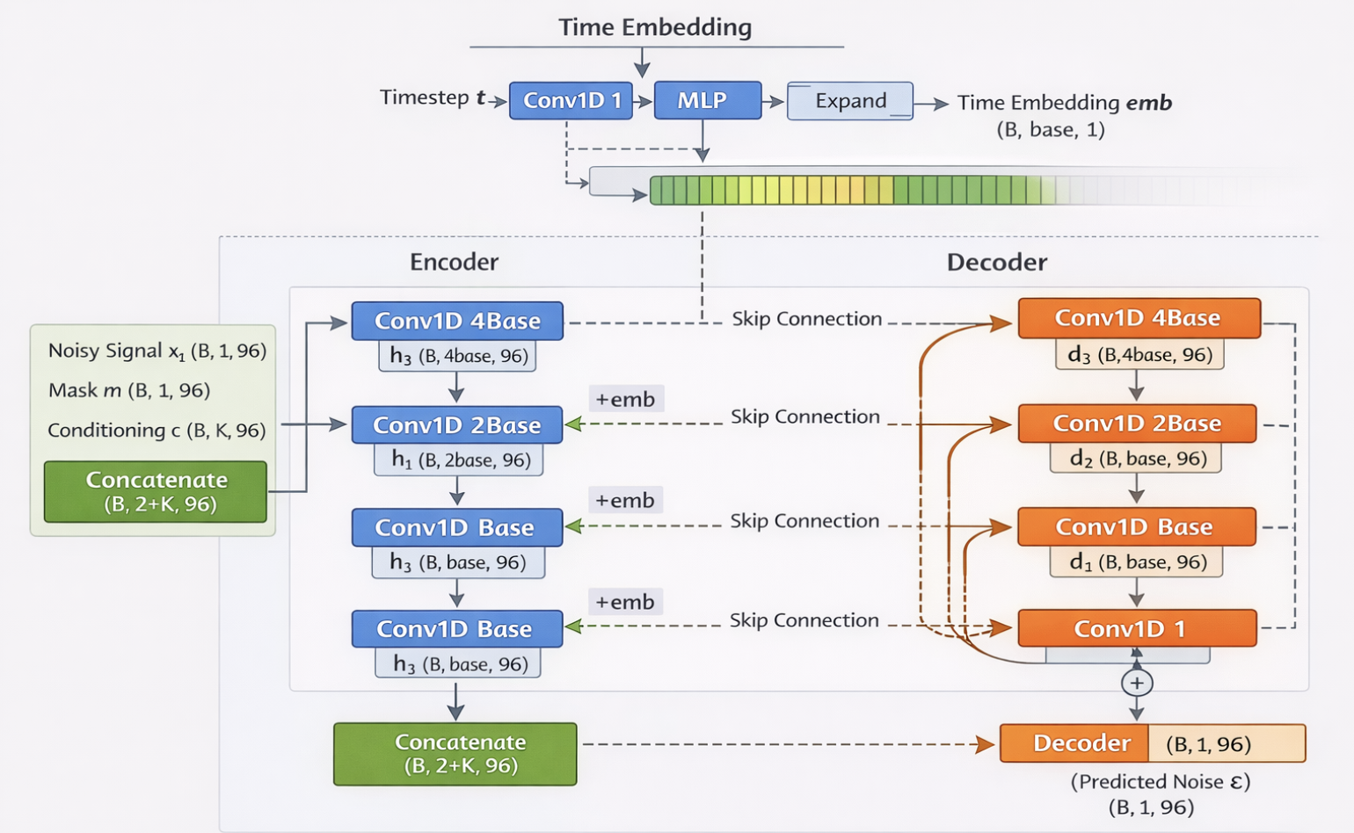

This concludes the methodology for Anomaly Imputation. Next we discuss how we perform Anomaly Detection with a Diffusion Inspired model.

F. Anomaly Detection with Diffusion
Anomaly Detection with Diffusion is a relatively new method in Time Series analysis. Here, we pursue a reconstruction based anomaly detection from time and frequency residuals that leverages Diffusion qualities with an autoencoder.

F.1 Training Process
Essentially, the Diffusion Model works by corrupting the data with progressive small amounts of Gaussian noise. Hence, the Neural Network learns the data distribution of the dataset.

In this section, we explain the equations and algorithm used in the Forward Process.

The forward process is a Markov chain whose every step consists of a mean added with a variance and is only dependent on the one prior step and not all the steps happening before.
$$q(x_{t}∣x_{t-1})=N(\sqrt{α_{t}}x_{t-1},(1-α_{t})I)$$ | (17)

Now, if we are to do step-wise Gaussian noise, we have the following:

$$x_{1}∼N(\sqrt{α_{1}}x_{0},(1-α_{1})I) \\ x_{2}∼N(\sqrt{α_{2}}x_{1},(1-α_{2})I) \\ ⋮$$
With some mathematics, these above equations can be simplified to one equation (below). This equation is powerful because at any timepoint, the noised output is purely determined using only the first input, $x_{0}$, without considering the intermediate x values.
$$x_{t}=\sqrt{{\overset{ˉ}{α}}_{t}}x_{0}+\sqrt{1-{\overset{ˉ}{α}}_{t}}ε$$  $${\overset{ˉ}{α}}_{t}=\prod_{s=1}^{t}{α_{s}}$$ | (18)
Now, we perform a parameterized trick in order to force the mean to be zero and the variance to be one as more noise is added. Accordingly, we create a beta that is composed of values which we call the “noise schedule”.
$β_{t}$: how much noise is added at step $t$
This is the noise schedule, we set it to: $β_{t}∼\text{Linear}({10}^{-4},0.02)$
$α_{t}=1-β_{t}$: how much signal is preserved
Hence, by rearranging, we come with the following equation:
$$q(x_{t}∣x_{t-1})=N \left(\sqrt{1-β_{t}} x_{t-1} , β_{t}I\right)$$ | (19)

Accordingly, when $t→T$, this means that the result of the forward process is an Isotropic Gaussian whereby the mean is zero and the variance is the same in every direction.
$$x_{T}≈N(0,I)$$ | (20)

In summary, the forward process is:
$$x_{0} → x_{1} → … → x_{T}≈N(0,I)$$

Additionally, we predict the noise via the neural network:
$$\hat{ε}=ε_{θ}(x_{t},t)$$ | (21)

and compute the loss as:
$$L(θ)=∥ε-ε_{θ}(x_{t},t)∥^{2}$$ | (22)

F.2 Time and Frequency Domain Reconstruction Errors
To determine anomalies, we will determine the Time-Domain and Frequency-Domain Reconstruction Errors which are basically a comparison of the input and the output. Together, they create a score whereby above a certain threshold, here 70%, the reconstruction is so large that it is deemed as an anomaly.

Time-domain and frequency-domain analyses are both used because some anomalies change time values (amplitude, spikes, offsets) while others disrupt structure and periodicity. Accordingly, both domains capture the comprehensive behaviour of the anomalies.

With regards to the Time-Domain Reconstruction Error, for any window $i,$ the MAE (“Mean Absolute Error”) is calculated. Essentially, it is the summed absolute differences of the input and output divided by W to get the average that is independent of the window size. It answers the question: on average, how far off is the reconstructed signal from the input signal?

$${\text{MAE}}_{\text{time}}^{\left(i\right)}=\frac{1}{W}\sum_{j=1}^{W}{∣x_{j}^{\left(i\right)}-{\hat{x}}_{j}^{\left(i\right)}∣}$$ | (23)

The Frequency-Domain Reconstruction Error answers the following question: how much does the spectral structure (such as periodicity) of the reconstructed signal differs from the input signal? The equations are the following:

First the “Discrete Fourier Transform” is done whereby the signal is decomposed into a set of sinusoidal frequency components that shows how much of each frequency is present.

$$X^{\left(i\right)}=F\{x^{\left(i\right)}\},{\hat{X}}^{\left(i\right)}=F\{{\hat{x}}^{\left(i\right)}\}$$ | (24)

Second the “Log-Magnitude Spectrum” compresses the range of a signal’s frequency components making relative spectral differences easier to compare.

$$R^{\left(i\right)}=log⁡(1+∣X^{\left(i\right)}∣)$$ | (25)

Finally, we combine both to determine the combined “Mean Absolute Error”.

$${\text{MAE}}_{\text{freq}}^{\left(i\right)}=\frac{1}{W}\sum_{k=1}^{W}{∣R_{k}^{\left(i\right)}-{\hat{R}}_{k}^{\left(i\right)}∣}$$ | (26)

F.3 Anomaly Score
Robust z-score normalization rescales values by subtracting the median and dividing by the median absolute deviation (MAD). Its purpose is to create a value that is resistant to outliers and skewed distributions.

The following are the equations for the Robust Z-Score Normalization for any given vector $v:$

For any vector $v$:
$$\text{median}(v)=\tilde{v} \\ \text{MAD}(v)=\text{median}\left(∣v − \tilde{v}∣\right)$$  Robust z-score:  $$z(v)=\frac{v-\tilde{v}}{\text{MAD}(v)+ϵ}$$ | (27)

Now, the Robust Z-Scores are used to determine the Combined Window-Level Anomaly Score. The equation is the following:

$$s^{\left(i\right)}=\frac{1}{2}\left[z\left({\text{MAE}}_{\text{time}}^{\left(i\right)}\right) + z\left({\text{MAE}}_{\text{freq}}^{\left(i\right)}\right)\right]$$  $$s_{k}=s^{\left(i\right)}∀ k∈[(i-1)W+1,iW]$$ | (28)
The anomalies are those whose scores are above a threshold determined during training. In our experiment, we set the threshold to be 70% empirically based. Below is the calculation. When ${\hat{y}}_{k}$ is 1, then it is an anomaly, otherwise, when 0, it is normal.
$${\hat{y}}_{k}=\left\{\begin{matrix}1 & \text{if }s_{k}>τ_{p} \\ 0 & \text{otherwise}\end{matrix}\right.$$ | (29)

F.4 Algorithm
The following, Algorithm II, describes how the Training and Inference are performed.

Algorithm II: “Anomaly Detection – Training and Inference”
TRAINING PROCESS
Inputs | - Training signal $s$ (active power)  - Window size $W=24$  - Diffusion steps $T=1000$  - UNet1D denoiser $f_{θ}(⋅)$  - Learning rate $η$
Training
Denoising Training (Loop)
Sample diffusion timestep | $$t∼\text{Uniform}\{0,…,T-1\}$$
Sample Gaussian Noise | $$ϵ∼N(0,I)$$
Forward Diffusion | $$β_{t}\text{ linearly spaced from }{10}^{-4}\text{ to }0.02 \\ α_{t}=1-β_{t},{\overset{ˉ}{α}}_{t}=\prod_{k=0}^{t}{α_{k}}$$  $$x_{t}=\sqrt{{\overset{ˉ}{α}}_{t}} x_{0}+\sqrt{1-{\overset{ˉ}{α}}_{t}} ϵ$$
Noise Prediction | $$\hat{ϵ}=f_{θ}(x_{t})$$
MSE Loss on Noise | $$L=∥\hat{ϵ}-ϵ∥_{2}^{2}$$
Update parameters | $$θ←θ-η∇_{θ}L$$
End Loop | trained model $f_{θ}$
Score Calibration
Score Calibration (after training)
Reconstruct training windows | $${\hat{X}}_{i}=f_{θ}(X_{i}),i=1,…,N$$
Time-domain reconstruction error | $${\text{mae}}_{t}(i)=\frac{1}{W}\sum_{j=1}^{W}{∣X_{i}[j]-{\hat{X}}_{i}[j]∣}$$
Frequency-domain reconstruction error | $$R_{i}=log\left(1 + ∣\text{FFT}(X_{i})∣\right),{\hat{R}}_{i}=log\left(1 + ∣\text{FFT}({\hat{X}}_{i})∣\right) \\ {\text{mae}}_{f}(i)=\frac{1}{W}\sum_{j=1}^{W}{∣R_{i}[j]-{\hat{R}}_{i}[j]∣}$$
Apply Robust Normalization | For a vector $v∈\{{\text{mae}}_{t},{\text{mae}}_{f}\}$:  $$z\left(v\right)=\frac{v-\text{median}\left(v\right)}{\text{MAD}\left(v\right)+{10}^{-6}}$$  $$\text{MAD}(v)=\text{median}(∣v-\text{median}(v)∣)$$
Compute Anomaly Score | $$S_{\text{train}}(i)=\frac{1}{2}(z({\text{mae}}_{t})(i)+z({\text{mae}}_{f})(i))$$
Select percentile-based threshold | $$τ=\text{percentile}(S_{\text{train}}, p)$$

INFERENCE TRAINING
Inputs | - Trained model $f_{θ}$  - Training score vector $S_{\text{train}}$  - Window length $W=24$  - Percentile $p$ (e.g., 70)
Single Pass Reconstruction | $$\hat{X}=f_{θ}(X)$$
Time residual | $${\text{mae}}_{t}(i)=\frac{1}{W}\sum_{j=1}^{W}{∣}X_{i}[j]-{\hat{X}}_{i}[j]∣$$
Frequency residual | $$R_{i}=log⁡(1+∣\text{FFT}(X_{i})∣),{\hat{R}}_{i}=log⁡(1+∣\text{FFT}({\hat{X}}_{i})∣) \\ {\text{mae}}_{f}(i)=\frac{1}{W}\sum_{j=1}^{W}{∣}R_{i}[j]-{\hat{R}}_{i}[j]∣$$
Robust z-score definition | $$z(v)=\frac{v-\text{median}(v)}{\text{MAD}(v)+{10}^{-6}}$$
Final score per window | $$S_{\text{win}}(i)=0.5(z({\text{mae}}_{t})(i)+z({\text{mae}}_{f})(i))$$
Threshold using training-score | $$τ=\text{percentile}(S_{\text{train}},p)$$
Anomaly Predictions | $${\hat{y}}_{\text{row}}=\left\{\begin{matrix}\text{anomaly} & S_{\text{row}}>τ \\ \text{normal} & \text{otherwise}\end{matrix}\right.$$

F.6 Architecture
The architecture of this Diffusion Model is essentially a UNet which is a family of neural network models characterized with an encoder and decoder with skip connections. The important characteristics is that the input and the output have the same dimensions and that the skip connections help preserve the characteristics of prior steps as is necessary when doing a reverse Diffusion process. Below, FIGURE IV, is the architecture we adopted. It is the simplest possible for a Diffusion Model.

figure iv. Anomaly Detection with Diffusion Architecture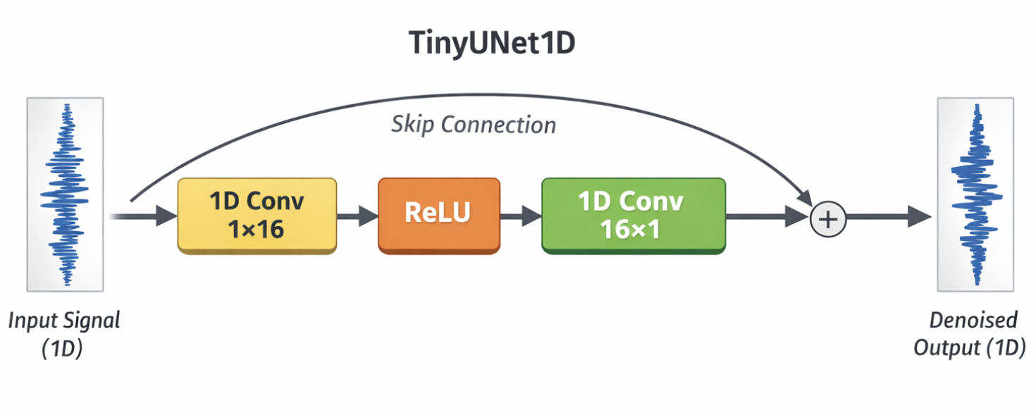

Results
In this section, we present the averaged statistics of both Inserted Anomalies and Diffusion Imputed Anomalies from each of the fourteen residences. These statistics include accuracy, precision, recall, f1_score, ActualNormal, ActualAnomaly, separation_delta, cohens_d, roc_auc, and pr_auc. The interpretation of these results is in the next section - Discussion.

Anomaly Insertion Statistics
Table IV. Anomaly Insertion Statistics
anomaly type | accuracy | precision | recall | f1_score | ActualNormal | ActualAnomaly | separation_delta | cohens_d | roc_auc | pr_auc
mirror | 0.697 | 0.002 | 0.192 | 0.003 | 52256.071 | 96.000 | 0.110 | 0.238 | 0.445 | 0.003
multistepchange | 0.699 | 0.004 | 0.496 | 0.009 | 52256.071 | 96.000 | -0.195 | -0.427 | 0.598 | 0.004
powercycling | 0.698 | 0.004 | 0.513 | 0.008 | 52256.071 | 96.000 | -0.213 | -0.464 | 0.606 | 0.004
repeating | 0.699 | 0.005 | 0.496 | 0.009 | 52256.071 | 96.000 | -0.195 | -0.429 | 0.598 | 0.005
stepchange | 0.699 | 0.005 | 0.531 | 0.010 | 52256.071 | 96.000 | -0.231 | -0.506 | 0.615 | 0.005
stuckmax | 0.699 | 0.005 | 0.567 | 0.010 | 52256.071 | 96.000 | -0.267 | -0.585 | 0.633 | 0.005
stuckmin | 0.697 | 0.001 | 0.174 | 0.003 | 52256.071 | 96.000 | 0.127 | 0.278 | 0.436 | 0.003

Anomaly Imputation Diffusion Statistics
Table V. Anomaly Imputation Diffusion Statistics
anomaly type | accuracy | precision | recall | f1_score | ActualNormal | ActualAnomaly | separation_delta | cohens_d | roc_auc | pr_auc
mirror | 0.686 | 0.002 | 0.228 | 0.004 | 52256.071 | 96.000 | 0.084 | 0.184 | 0.458 | 0.003
multistepchange | 0.687 | 0.003 | 0.389 | 0.006 | 52256.071 | 96.000 | -0.077 | -0.167 | 0.538 | 0.004
powercycling | 0.687 | 0.004 | 0.514 | 0.008 | 52256.071 | 96.000 | -0.202 | -0.443 | 0.601 | 0.004
repeating | 0.687 | 0.004 | 0.532 | 0.009 | 52256.071 | 96.000 | -0.220 | -0.481 | 0.610 | 0.004
stepchange | 0.687 | 0.003 | 0.425 | 0.007 | 52256.071 | 96.000 | -0.113 | -0.245 | 0.556 | 0.004
stuckmax | 0.688 | 0.005 | 0.550 | 0.009 | 52256.071 | 96.000 | -0.238 | -0.522 | 0.619 | 0.004
stuckmin | 0.686 | 0.002 | 0.211 | 0.003 | 52256.071 | 96.000 | 0.102 | 0.223 | 0.449 | 0.003

Anomaly Imputation-minus-Diffusion Statistics
Table VI. Anomaly Diffusion minus Anomaly Inserted Statistics
anomaly type | sep_d imp | sep_d ins | sep_d diff | co_d imp | co_d ins | co_d diff | roc_auc diff | pr_auc diff
mirror | 0.084 | 0.11 | -0.026 | 0.184 | 0.238 | -0.054 | 0.013 | 0
multistepchange | -0.077 | -0.195 | 0.118 | -0.167 | -0.427 | 0.26 | -0.06 | 0
powercycling | -0.202 | -0.213 | 0.011 | -0.443 | -0.464 | 0.021 | -0.005 | 0
repeating | -0.22 | -0.195 | -0.025 | -0.481 | -0.429 | -0.052 | 0.012 | -0.001
stepchange | -0.113 | -0.231 | 0.118 | -0.245 | -0.506 | 0.261 | -0.059 | -0.001
stuckmax | -0.238 | -0.267 | 0.029 | -0.522 | -0.585 | 0.063 | -0.014 | -0.001
stuckmin | 0.102 | 0.127 | -0.025 | 0.223 | 0.278 | -0.055 | 0.013 | 0
average | -0.095 | -0.123 | 0.029 | -0.207 | -0.271 | 0.063 | -0.014 | 0.000

Discussions
In this discussion, we provide a comprehensive analysis of the results based on the previous tables, TABLES IV/V/VI.

It is first important to understand that there is a very large class imbalance with the following results:
- Total number of Normal points ≈ 52,256
- Total number of Anomaly points = 96
- This results in an anomaly rate of ≈ 0.18%
Accordingly, across both Inserted and Imputed we get:
- Accuracy ≈ 0.69 is meaningless
- Precision ≈ 0.002–0.005 is expected
- F1 is suppressed by precision
Hence, accuracy, precision, and F1 are not strong identifiers in this experiment, and we must rely on others: ROC-AUC, PR-AUC, Separation Delta, and Cohen’s d.

With regards to the differences in ROC-AUC we see that these absolute differences are small, on average 0.014. This translates to the anomaly detection finding imputed anomalies similarly to inserted anomalies.

The near-zero difference in PR-AUC indicate that that imputation does not significantly change precision-recall behaviour. Hence, both imputation and insertion handle the severe class imbalance similarly.

With regards to Recall, the order, from high to low, for Imputated is: stuckmax, repeating, pwoercycling, stepchange, multistepchange, mirror, and stuckmin. With regards to Inserted it is: stuckmax, stepchange, powercycling, repeating, multistepchange, mirror, and stuckmin. Accordingly, these orderings are similar, thus, indicating similar detection behaviour for the same anomaly types.

Separation Delta expresses how much higher or lower anomalies are when compared to normal scores on average. With values close to 0, there is much overlap, hence, the anomalies look normal. With large positive/negative, they are further apart, hence, the anomalies are obvious. The sign tells which direction the anomaly scores move, but what matters is the magnitude. Accordingly, from out table, the imputed anomaly is closer to normal behaviour according to the absolute averages of 0.095 compared to 0.123. This implies that imputed anomaly resembles closer to the normal data than the inserted anomaly.

Cohen’s d measures the effect size between normal and anomaly distributions. Overall, the magnitude of Cohen’s d is smaller under imputation (0.207 compared to 0.271), thus, the anomalies created by imputation are closer to the normal distribution.

In conclusions, anomaly insertion and anomaly imputation produce anomalies that are detected similarly. However, imputed anomalies are less different from normal behavior, thus, rendering them more realistic. This demonstrates that anomaly imputation provides a more “realistic” way to create synthetic anomalies that are more realistic than directly inserting artificial anomalies.

Conclusions
Overall imputation reshapes the anomaly structure and preserves detectability (from insertion-based to diffusion-based), hence, is not just adding noise or trivial anomalies. We have empirically proven that the Imputated model resembles closer to the Normal model than the Inserted model. Our objectives are fulfilled whereby imputation produces context-aware and realistic anomaly patterns appropriate for anomaly analysis.

Future Work
The Diffusion Imputation functionality could be extended by allowing greater control over anomaly structure characteristics. For example, anomaly attributes could consider features for duration, amplitude, and temporal pattern. With such more nuanced control, more sophisticated anomalies could be created, thus, gaining insight into what anomaly characteristics affect detection and having a broader span of various anomalies.

We could extend to a multivariate time series by incorporating weather, socioeconomic status, and more appliances. Here, we created anomalies at the appliance level (fridge) focusing only on Active Power.

Finally, to further validate our imputation, it would be essential to compare our imputation anomalies with expert-annotated or real fault events, thus, further validating our imputation as a real-world monitoring system. This was not pursued in this project due to no readily available datasets with this characteristic.

Acknowledgment
The authors acknowledge the use of ChatGPT in assisting with the development and drafting of code used in this work. All outputs generated by these tools were critically reviewed, validated, and adapted by the authors to ensure accuracy and alignment with the research goals.

References

[1] L. N. Valli and N. Sujatha, “Time Series Analysis in Data Science: Forecasting Trends and Anomalies,” in 2024 5th International Conference on Smart Electronics and Communication (ICOSEC), Sep. 2024, pp. 15–20. doi: 10.1109/ICOSEC61587.2024.10722052.
[2] H.-S. Wu, “A survey of research on anomaly detection for time series,” in 2016 13th International Computer Conference on Wavelet Active Media Technology and Information Processing (ICCWAMTIP), Dec. 2016, pp. 426–431. doi: 10.1109/ICCWAMTIP.2016.8079887.
[3] G. Zhu, H. Zhao, H. Liu, and H. Sun, “A Novel LSTM-GAN Algorithm for Time Series Anomaly Detection,” in 2019 Prognostics and System Health Management Conference (PHM-Qingdao), Oct. 2019, pp. 1–6. doi: 10.1109/PHM-Qingdao46334.2019.8942842.
[4] S. Mao, J. Guo, T. Gu, and Z. Ma, ..“Dis-AE-LSTM: Generative Adversarial Networks for Anomaly Detection of Time Series Data,” in 2020 International Conference on Artificial Intelligence and Computer Engineering (ICAICE), Oct. 2020, pp. 330–336. doi: 10.1109/ICAICE51518.2020.00070.
[5] Y. Choi, H. Lim, H. Choi, and I.-J. Kim, “GAN-Based Anomaly Detection and Localization of Multivariate Time Series Data for Power Plant,” in 2020 IEEE International Conference on Big Data and Smart Computing (BigComp), Feb. 2020, pp. 71–74. doi: 10.1109/BigComp48618.2020.00-97.
[6] “Hart1985.pdf.” Accessed: Jan. 02, 2026. [Online]. Available: https://www.georgehart.com/research/Hart1985.pdf
[7] H. Yang et al., “Adversarial Data Anomaly Detection and Calibration for Nonintrusive Load Monitoring,” IEEE Internet Things J., vol. 12, no. 1, pp. 544–555, Jan. 2025, doi: 10.1109/JIOT.2024.3463730.
[8] G. A. Raiker, D. L. Ravi, V. V. Baligar, and S. R. B, “Demand Response Based on Anomaly Detection and Non-Intrusive Load Monitoring,” in 2024 IEEE International Conference on Power Electronics, Drives and Energy Systems (PEDES), Dec. 2024, pp. 1–5. doi: 10.1109/PEDES61459.2024.10961548.
[9] M. Afaq, N. U. Islam, and S. M. Shah, “Enhanced Load Recognition and Anomaly Detection in Non-Intrusive Load Monitoring Using Transfer Learning,” in 2025 IEEE International Conference on Electronics, Computing and Communication Technologies (CONECCT), Jul. 2025, pp. 1–6. doi: 10.1109/CONECCT65861.2025.11306884.
[10] D. Azzalini, B. Flammini, C. A. Emanuele, A. Guadagno, E. Ragaini, and F. Amigoni, “An empirical evaluation of deep autoencoders for anomaly detection in the electricity consumption of buildings,” Energy Build., vol. 327, p. 115069, Jan. 2025, doi: 10.1016/j.enbuild.2024.115069.
[11] R. Wu and E. J. Keogh, “Current Time Series Anomaly Detection Benchmarks are Flawed and are Creating the Illusion of Progress,” IEEE Trans. Knowl. Data Eng., vol. 35, no. 3, pp. 2421–2429, Mar. 2023, doi: 10.1109/TKDE.2021.3112126.
[12] H. A. Dau et al., “The UCR Time Series Archive,” Sep. 09, 2019, arXiv: arXiv:1810.07758. doi: 10.48550/arXiv.1810.07758.
[13] J. Sohl-Dickstein, E. A. Weiss, N. Maheswaranathan, and S. Ganguli, “Deep Unsupervised Learning using Nonequilibrium Thermodynamics,” Nov. 18, 2015, arXiv: arXiv:1503.03585. doi: 10.48550/arXiv.1503.03585.
[14] L. Lin, Z. Li, R. Li, X. Li, and J. Gao, “Diffusion Models for Time Series Applications: A Survey,” May 01, 2023, arXiv: arXiv:2305.00624. doi: 10.48550/arXiv.2305.00624.
[15] N. Lin, P. Palensky, and P. P. Vergara, “EnergyDiff: Universal Time-Series Energy Data Generation Using Diffusion Models,” IEEE Trans. Smart Grid, vol. 16, no. 5, pp. 4252–4265, Sep. 2025, doi: 10.1109/TSG.2025.3581472.
[16] D. Sagawa and K. Tanaka, “Generation of Household Electricity Demand Data Using Diffusion Models,” in 2025 International Conference on Clean Electrical Power (ICCEP), Jun. 2025, pp. 794–797. doi: 10.1109/ICCEP65222.2025.11143722.
[17] Z. Wang, D. Chen, C. Wan, Q. Wang, B. Li, and L. Zhu, “ShapeDiff: A Universal Source-Load Time Series Anomaly Detection and Imputation Model,” in 2025 4th International Conference on Smart Grid and Green Energy (ICSGGE), Feb. 2025, pp. 203–208. doi: 10.1109/ICSGGE64667.2025.10984485.
[18] J. M. L. Alcaraz and D. Ai, “Diffusion-based Time Series Imputation and Forecasting with Structured State Space Models”.
[19] Y. Tashiro, J. Song, Y. Song, and S. Ermon, “CSDI: Conditional Score-based Diffusion Models for Probabilistic Time Series Imputation”.
[20] G. Bishop, T. Si, and H. Gong, “Blue Noise-based Generative Models for the Imputation of Time-series Data,” in 2025 15th International Conference on Information Science and Technology (ICIST), Dec. 2025, pp. 256–259. doi: 10.1109/ICIST66592.2025.11306560.
[21] Z. Yang, H. Dong, H. Zhang, and R. Wang, “Conditional Time Series Diffusion Model for High-Speed Train Multi-Sensor Signals Imputation,” IEEE Trans. Intell. Transp. Syst., vol. 26, no. 8, pp. 12518–12531, Aug. 2025, doi: 10.1109/TITS.2025.3557088.
[22] J. Liu et al., “A Survey on Diffusion Models for Anomaly Detection,” Feb. 27, 2025, arXiv: arXiv:2501.11430. doi: 10.48550/arXiv.2501.11430.
[23] A. Bhosale, S. Mukherjee, B. Banerjee, and F. Cuzzolin, “Anomaly detection using Diffusion-based methods,” Dec. 10, 2024, arXiv: arXiv:2412.07539. doi: 10.48550/arXiv.2412.07539.
[24] V. Livernoche, V. Jain, Y. Hezaveh, and S. Ravanbakhsh, “On Diffusion Modeling for Anomaly Detection,” Mar. 25, 2025, arXiv: arXiv:2305.18593. doi: 10.48550/arXiv.2305.18593.
[25] X. Li et al., “One-for-More: Continual Diffusion Model for Anomaly Detection”.
[26] J. Choi, M. Kim, and J. Hong, “MAGIC: Mask-Guided Diffusion Inpainting with Multi-Level Perturbations and Context-Aware Alignment for Few-Shot Anomaly Generation,” Jul. 03, 2025, arXiv: arXiv:2507.02314. doi: 10.48550/arXiv.2507.02314.
[27] J. Song et al., “DefectFill: Realistic Defect Generation with Inpainting Diffusion Model for Visual Inspection”.

